

Copyright © 2017 by Educational Testing Service. All rights reserved. ETS, the ETS logo and HiSET are registered trademarks of Educational Testing Service (ETS). MEASURING THE POWER OF LEARNING is a trademark of ETS. Test items copyright © 2001, 2003, 2007 by The University of Iowa. All rights reserved. Used under license from Houghton Mifflin Harcourt. THE IOWA TESTS® is a registered trademark of Houghton Mifflin Harcourt Publishing Company. Test items from Iowa Testing Programs copyright © 2017 by The University of Iowa. All rights reserved.
SocialStudies
Directions
Time − 35 minutes
25 Questions
This is a test of your skills in analyzing social studies information. Read each question and decide which of the four alternatives best answers the question. Then mark your choice on your answer sheet.
Sometimes several questions are based on the same material. You should carefully read this material and then answer the questions.
Work as quickly as you can without becoming careless. Do not spend too much time on any question that is difficult for you to answer. Instead, skip it and return to it later if you have time. Try to answer every question even if you have to guess.
Mark all your answers on the answer sheet. Give only one answer to each question.
If you decide to change one of your answers, be sure to erase the first mark completely.
Be sure that the number of the question you are answering matches the number of the row of answer choices you are marking on your answer sheet. The answer sheet may contain more rows than you need.

Questions 1 through 8 refer to the following information.
The table below shows the ten most populous U.S. cities from 1800 – 2000 in order from the most populous to the tenth most populous.
 | 1800 | 1850 | 1900 | 1950 | 2000
1 | New York, NY | New York, NY | New York, NY | New York, NY | New York, NY
2 | Philadelphia, PA | Baltimore, MD | Chicago, IL | Chicago, IL | Los Angeles, CA
3 | Baltimore, MD | Boston, MA | Philadelphia, PA | Philadelphia, PA | Chicago, IL
4 | Boston, MA | Philadelphia, PA | St. Louis, MO | Los Angeles, CA | Houston, TX
5 | Charleston, SC | New Orleans, LA | Boston, MA | Detroit, MI | Philadelphia, PA
6 | Northern Liberties, PA | Cincinnati, OH | Baltimore, MD | Baltimore, MD | Phoenix, AZ
7 | Southwark, PA | Brooklyn, NY | Cleveland, OH | Cleveland, OH | San Diego, CA
8 | Salem, MA | St. Louis, MO | Buffalo, NY | St. Louis, MO | Dallas, TX
9 | Providence, RI | Spring Garden, PA | San Francisco, CA | Washington, D.C. | San Antonio, TX
10 | Norfolk, VA | Albany, NY | Cincinnati, OH | Boston, MA | Detroit, MI
3
1  In 1850, how many of the ten most populous cities were located in states that were part of the original thirteen colonies?  - 5  - 6  - 7  - 8  2  In which of the following time periods was population growth in the South and West most evident?  - 1800 – 1850  - 1850 – 1900  - 1900 – 1950  - 1950 – 2000 | __  __  __  __  __  __  __  __  __  __  __  __  __  __  __  __  __  __  __  __  __  __  __  __  __  __  __  __  __  __  __  __  __  __  __  __  __  __  __  __  __  __  __  __  __  __  __ | 3  Which of the following two statements, if either, is supported by the information in the table?  - There were fewer people living in the Northeast in 2000 than in 1800.  - The list of the ten most populous cities in 2050 will be the same as the 2000 list.  - I only  - II only  - Both I and II  - Neither I nor II

4  Which of the following occurrences most likely explains why Detroit appears on the list of most populous U.S. cities in 1950?  - The growth in trade with Canada  - The completion of the Erie Canal  - The growth of the automobile industry  - The end of the severe drought in the Midwest  5  Which of these historical events best explains why San Francisco was part of the list in 1900?  - The end of the Civil War  - The completion of the transcontinental railroad  - The beginning of the Pony Express service D. The development of gas-powered automobiles  6  Which conclusion can be drawn from the information in this table?  - Texas was the most populous state in 2000.  - New York City will continue to see a steady rise in population.  - From 1800 to 2000, the majority of the ten most populous U.S. cities have shifted from states in the North and East to states in the West and South.  - From 1800 to 2000, the majority of the ten most populous U.S. cities have shifted from states in the South and West to states in the North and East. | __  __  __  __  __  __  __  __  __  __  __  __  __  __  __  __  __  __  __  __  __  __  __  __  __  __  __  __  __  __  __  __  __  __  __  __  __  __  __  __  __  __  __  __  __  __  __  __  __  __  __  __  __  __  __  __  __  __  __  __  __  __  __  __  __  __  __  __  __ __  5__ | 7  Which region has the fewest cities listed in this table?  - Northwest  - Northeast  - Southwest  - Southeast  8  Which city in this table is NOT a part of any state?  A. New York City B. Washington, D.C.  - St. Louis  - Detroit

__
Questions 9 through 13 refer to the following information.
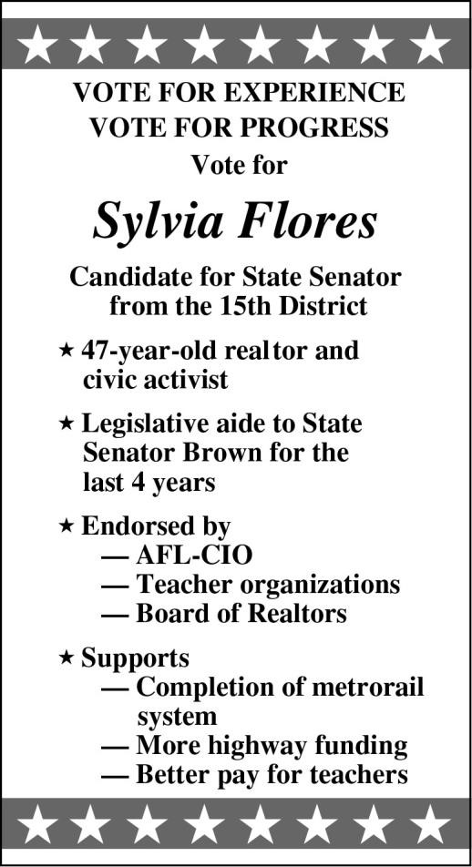
11  Which of the following activities would have contributed LEAST to Flores’s being called a “civic activist”?  A. Her work for a parent-teacher association B. Her service on the city council  - Her efforts to raise money to remodel the city library  - Her ownership of a real estate business  12  Which of the following might a voter most expect if Flores is elected?  - She will probably support right-to-work laws.  - She will probably be appointed to the same Senate committees to which Senator Brown had been appointed.  - She will probably support increased state |  | __  __  __  __  __  __  __  __  __  __  __  __  __  __  __  __  __  __  __  __  __  __  __  __  __  __  __  __  __  __  __  __  __  __  __  __  __  __  __  __  __  __  __  __  __  __  __  __  __  __  __  __  __  __  __  __  __  __  __  __  __  __  __  __  __  __  __  __  __  __  __  __  __  __  __  __  7__  __ | 9  Which of the following statements is most strongly supported by the information in the poster?  - Flores is a member of a union.  - Flores is strongly interested in public affairs. C. Flores is an advocate of lower property taxes.  D. Flores has received the endorsement of retiring Senator Brown.  13  Flores apparently believes that her association with Senator Brown will be regarded as a  - professional embarrassment.  - political asset.  - strong rivalry.  - minor aspect of her experience.
D. | spending for the public schools.  She will probably oppose an increase in the state gasoline tax.

Questions 14 through 16 refer to the following information.
The sophomore class of Douglas High School raises money through a yearly raffle project. The profits are used to improve the school. To help decide on the price of the raffle tickets this year, the class used the graphs below. They provide information about the ticket sales and the net profits of the raffle projects for the last five years. The raffle expenses have stayed relatively constant during these years.
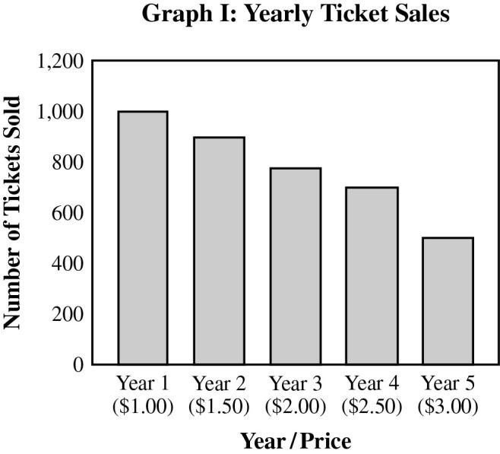
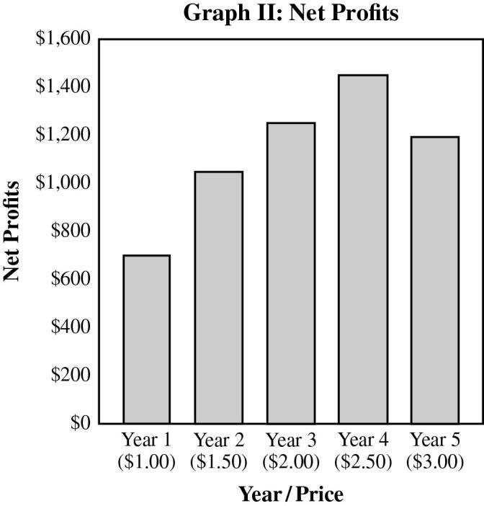
14  Graph I illustrates the principle that when a product is NOT a necessity,  - profits equal the excess of the product’s value over production costs.  - price is established when demand exceeds supply.  - the higher the product’s price, the lower its demand.  - the higher the product’s price, the lower its supply.  15  Which of the following generalizations is supported by the graphs?  - Profits are greatest when prices are low.  - Profits are influenced by the relationship between price and demand.  - Profits increase when the price of a product increases.  - Demand for a product cannot be predicted from its price. | __  __  __  __  __  __  __  __  __  __  __  __  __  __  __  __  __  __  __  __  __  __  __  __  __  __  __  __  __  __  __  __  __  __  __  __  __  __  __  __  __  __  __  __  __  __  __  __  __  __  __  __  __  __  __  __  __  __  __  __  __  __  __  __  __  __  __  __  __ __  9__ | 16  Based on the information in the graphs, at what ticket price would the class be most likely to earn the highest profits?  - $1.50  - $2.00  - $2.50  - $3.00

__
Questions 17 and 18 refer to the following information.
The poster below is from World War I.
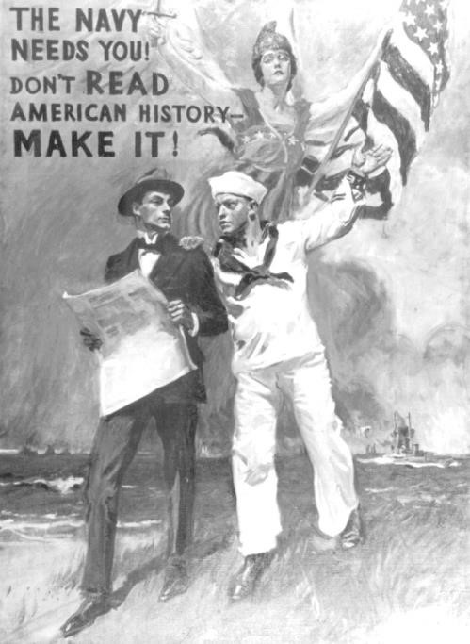
17 __

The Navy needs you!

Courtesy of Library of Congress # LC
-
USZC4
-
8890
.

__ In the poster, the man with the newspaper most __ likely represents __
__
- newspaper reporters. __
__
- former veterans. __
- potential recruits. ____
- members of Congress. __
__
__
__
__
__
__
__
__
__
__
__
__
__
__
__
__
__
__
__
__
__
__
__
__
__
__
__
__
_

11
18
This poster was most likely designed to appeal to all of the following EXCEPT a person’s A. desire for adventure.
- feelings of patriotism.
- sense of responsibility.
- need for financial security.

19  Which statement about a candidate running for president would be the most difficult to prove or disprove?  - Candidate A visited all fifty states in the last year.  - Candidate A has a more reasonable stance on taxes than candidate B.  - Candidate B voted in favor of a bill that would raise income tax rates.  - Candidate B has received more campaign contributions than candidate A.  20  Which of the following locations would be expected to have the most hours of sunlight on January 15?  - 50°N 20°E  - 10°N 100°E  - 10°S 100°W  - 50°S 20°W  21  Which of the following is the best example of an investment in human resources?  - A company provides educational programs for its employees.  - A company offers special discounts to some customers.  - A person buys stock in a newly formed company.  - A company acquires a machine that can do the work of several people. | __  __  __  __  __  __  __  __  __  __  __  __  __  __  __  __  __  __  __  __  __  __  __  __  __  __  __  __  __  __  __  __  __  __  __  __  __  __  __  __  __  __  __  __  __  __  __  __  __  __  __  __  __  __  __  __  __  __  __  __  __  __  __  __  __  __  __  __  __ __  12____ | 22  Which of the following people would be LEAST  likely to favor a city’s proposed downtown redevelopment plan?  - Someone who is financing a new office building in the downtown area  - A member of the city board that recommended the project  - A longtime resident of an apartment building targeted for demolition  - A partner in the architectural firm that would develop the proposed plan  23  Which of the following actions would probably NOT be protected by the constitutional guarantee of freedom of speech and freedom of the press?  - A newspaper columnist falsely accusing a city official of stealing funds  - A senator questioning the qualifications of a
 |  | C.  D. | presidential appointee  A radio commentator raising doubts about the ability of a political candidate  An editorial writer criticizing the policies of a police chief
__
__
24  Consider the diagram. | __  __  __  __  __ | 25  Which of the following statements would be most difficult to prove or disprove?
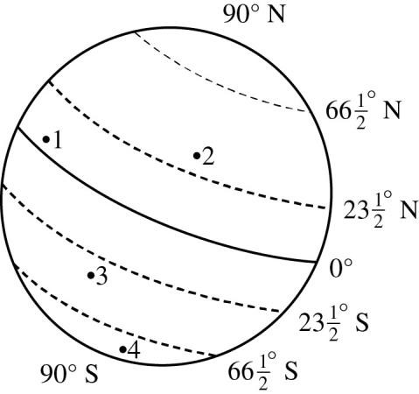
__ A. The United States should impose import
__
__ taxes on goods from countries that do not __ allow access to their markets.
__
__ B. The United States does not impose any __ import taxes on European goods.
__
__ C. Import taxes on goods from Latin America
__ are lower today than they were five years
__ ago.
__
__ D. Import taxes on farm machinery are greater __ than those on automobiles.
__
__
__
__
__ Which point on the diagram of Earth is in the __ tropical zone? __
__
- 1 __
__
- 2 __
- 3 ____
- 4 __
__
__

__
__
__
__
__
__
__
__
__
__
__
__
__
__
__
__
__
__
__
__
__
__
__
__
__
__
__
__
__
__
__
__
__
__
__
__

13__
__
__

NO TEST MATERIAL ON THIS PAGE

HiSET Answer Key and Rationales
Sequence Number | Correct Response | Content Category | Question Difficulty
1 | C | I. History | Medium
Rationale
Option C is correct because #5 New Orleans, #6 Cincinnati, and #8 St. Louis are located in regions that were not part of the original thirteen colonies.
Sequence Number | Correct Response | Content Category | Question Difficulty
2 | D | I. History | Medium
Rationale
Option D is correct because by 2000 there were six cities in the top ten that were in the southern or the western part of the United States, as opposed to 1950 where there was only one.
Sequence Number | Correct Response | Content Category | Question Difficulty
3 | D | I. History | Medium
Rationale
Option D is correct because the table does not give you population numbers for the entire Northeast region, and you cannot predict what the top ten cities will be in 2050 by looking at this table.
Sequence Number | Correct Response | Content Category | Question Difficulty
4 | C | I. History | Medium
Rationale
Option C is correct because Detroit was the location of a large number of automobile manufacturing plants during this time. This created many jobs and helped increase the population of the region.
Sequence Number | Correct Response | Content Category | Question Difficulty
5 | B | I. History | Medium
Rationale

Option B is correct because completion of the transcontinental railroad made travel to the western part of the United States much easier. It connected the urban areas in the eastern United States to the less populated areas in the western United States.

Sequence Number | Correct Response | Content Category | Question Difficulty
6 | C | I. History | Medium
Rationale
Option C is correct because over the 200-year span shown on this table, populations have moved from the northern and eastern regions of the United States to other parts of the country. The western and southern regions have experienced the greatest growth over this period because the regions offered more opportunities for jobs, land ownership, etc.
Sequence Number | Correct Response | Content Category | Question Difficulty
7 | A | IV. Geography | Medium
Rationale
Option A is correct because there are no cities from the Northwest region listed in this table.
Sequence Number | Correct Response | Content Category | Question Difficulty
8 | B | IV. Geography | Easy
Rationale
Option B is correct because the District of Columbia is a special district for the capital and not part of any state.
In 1790 the United States government passed the Residence Act, creating a separate region along the Potomac River that would contain the three branches of government (executive, legislative, and judicial). The states could not agree on a location for the capital, so this region was made independent.
Sequence Number | Correct Response | Content Category | Question Difficulty
9 | B | II. Civics/Government | Medium
Rationale
Option B is correct because the poster states that the candidate is a civic activist and is endorsed by the AFLCIO, teacher organizations, and realtors. The poster also indicates that the candidate supports improvements in transportation and increased pay for educators. These actions and organizations are all related to public affairs.
Sequence Number | Correct Response | Content Category | Question Difficulty
10 | A | II. Civics/Government | Medium
Rationale
Option A is correct because the statements contained in the poster are actual facts about the candidate, her affiliations, and campaign platform.

Sequence Number | Correct Response | Content Category | Question Difficulty
11 | D | II. Civics/Government | Easy
Rationale
Option D is correct because owning a business only benefits the owner, and the business only provides services to individuals interested in buying or selling homes. The business does not benefit the public at large.
Sequence Number | Correct Response | Content Category | Question Difficulty
12 | C | II. Civics/Government | Easy
Rationale
Option C is correct because she is endorsed by teacher organizations, and part of her campaign platform is for teachers to be paid more.
Sequence Number | Correct Response | Content Category | Question Difficulty
13 | B | II. Civics/Government | Medium
Rationale
Option B is correct because working as a legislative aide demonstrates her political experience.
Sequence Number | Correct Response | Content Category | Question Difficulty
14 | C | III. Economics | Medium
Rationale
Option C is correct because consumers view non-necessities in terms of price and affordability. If products are reasonably priced, then demand will usually balance supply. However, if the price exceeds affordability, then a surplus will exist because of the decrease in demand.
Sequence Number | Correct Response | Content Category | Question Difficulty
15 | B | III. Economics | Medium
Rationale
Option B is correct because the price point of a good will determine the amount of profits generated based on demand. A good at the appropriate price point will create a healthy demand and, therefore, generate the maximum amount of revenue.

Sequence Number | Correct Response | Content Category | Question Difficulty
16 | C | III. Economics | Medium
Rationale
Option C is correct because profits were highest at this price point.
Sequence Number | Correct Response | Content Category | Question Difficulty
17 | C | I. History | Medium
Rationale
Option C is correct because he represents the individual who is being persuaded to join the navy and make history rather than read about it in the newspaper.
Sequence Number | Correct Response | Content Category | Question Difficulty
18 | D | I. History | Easy
Rationale
Option D is correct because the poster does not mention how much the navy is willing to pay recruits.
Sequence Number | Correct Response | Content Category | Question Difficulty
19 | B | II. Civics/Government | Medium
Rationale
Option B is correct because it is an opinion. How reasonable a candidate’s stance on taxes is a matter of opinion and may vary from citizen to citizen, which would make it difficult to prove or disprove.
Sequence Number | Correct Response | Content Category | Question Difficulty
20 | D | IV. Geography | Medium
Rationale
Option D is correct because the seasons are reversed in the Northern and Southern Hemispheres. January in the Southern Hemisphere would represent the summer season. Also, since option D is the location farthest south, it would receive the most sunlight.

Sequence Number | Correct Response | Content Category | Question Difficulty
21 | A | III. Economics | Medium
Rationale
Option A is correct because it deals with the human element of a workforce of an organization, business, industry, or economy.
Sequence Number | Correct Response | Content Category | Question Difficulty
22 | C | III. Economics | Medium
Rationale
Option C is correct because an individual in this situation will be losing his or her longtime residence, while the others would benefit from the proposed plan.
Sequence Number | Correct Response | Content Category | Question Difficulty
23 | A | II. Civics/Government | Medium
Rationale
Option A is correct because even though the First Amendment protects the freedom of speech and the press, it does not protect speech or press that leads to illegal activity, imminent violence, obscenity, defamation, or libel.
Sequence Number | Correct Response | Content Category | Question Difficulty
24 | A | IV. Geography | Medium
Rationale
Option A is correct because areas nearest the equator have tropical climates.

Sequence Number | Correct Response | Content Category | Question Difficulty
25 | A | III. Economics | Medium
Rationale
Option A is correct because it is discussing actions that would take place in the future. This makes it difficult to prove or disprove.

